**Project statement:**

The goal of this project is to help normal people get a better understanding of blind by creating an experience of walking in highly blurred or black environment only with the help of sound. You can control the movement of your character with arrow key in the keyboard. The story is about a person who suddenly become blind and need to go to the hospital nearby and finally go back home safely.

**Specific goals for the project:**

Part 1. Develop a program with a circle controlled by arrow key. This circle will be the user-controlled “character”.

Part 2. Write a program to create 3 maps (one room of home, street, one room of hospital) using shapes and images. The scenes will change with conditional statement.

Part 3. Write a program to test if “character” intersects with objects or boundaries in maps. This will be used to determine if the “character” collides with the object or boundaries.

Part 4. Write a program to change HP of “character”. The HP will decrease by 1 once the “character” collides with objects (except car). When the HP equals to 0, the scene will change (enter tutorial mode or restart). If “character” is collided by a car, the circle will become a bunch of small circles and change their color to red.

Part 5. Write a program to integrate sound (Knock on the wall, Tripped by an object, Hit by a car, Car,

Ambulance, White Cane, Traffic light, People, Character, Doctor).

Part 6. Write a program to create visualization of echo. The echo is used to simulate how the “character” use a white cane. When the “character” moves, display an echo (a set of outwardly spreading concentric circles) in the direction of the movement of “character”.

Part 7. Write a program to test if “echo” intersects with objects or boundaries in maps. It will display a new echo with weaker effect in the site where they intersect.

Part 8. Write a program to create blur effect in display window. This will be used to simulate low vision.

Part 9. Write a program to display a dark picture with effect of crafted randomness and changes of light. This will be used to simulate blind. The variation of picture will be determined by the movement of “character”.

Further goal:

Control the movement of “character” with speak library. You will create echo effect when you speak, and the strength of the echo depends on the volume of your voice.

**Resources:**

Game:

Dark Echo <http://www.darkechogame.com/>

A Blind Legend <https://www.youtube.com/watch?v=izRCSaPWr2o>

Blindscape <https://www.youtube.com/watch?v=u-q_k0-pIcc>

Blind drive <https://www.youtube.com/watch?v=Fa1XetWE79Q>

Hands On: Panoramical <https://www.youtube.com/watch?v=Ta2L3Z7OMng&list=PLZFXcGXpOcDuqwfosiHokY2PyZDQrwhtM&index=2>

Echo/Wave/Ripples:

<https://www.openprocessing.org/sketch/377240>

<https://www.openprocessing.org/sketch/582277>

<https://www.openprocessing.org/sketch/446986>

Blind simulation:

<https://www.youtube.com/watch?v=rpzSs0c-xyM>

<https://simulator.seenow.org/webgl-camera.html>

<https://www.youtube.com/watch?v=PPGTfUr6O8o>

<https://www.youtube.com/watch?annotation_id=annotation_721942683&feature=iv&src_vid=PPGTfUr6O8o&v=hlcx_q8u_YI>

How Blind People Cross The Street Alone:

<https://www.youtube.com/watch?v=48DqdwzftnQ>

Movement and Orientation: Use Your Senses:

<http://www.visionaware.org/info/everyday-living/essential-skills/an-introduction-to-orientation-and-mobility-skills/indoor-movement-and-orientation-with-vision-impairment/1235>

Human echolocation:

<https://en.wikipedia.org/wiki/Human_echolocation>

**Tasks:**

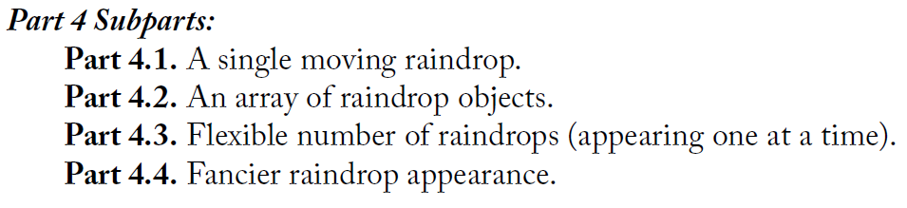

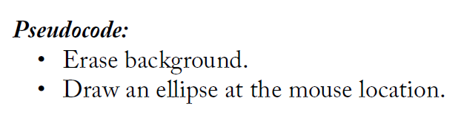

**Part 1.** Develop a program with a circle controlled by arrow key. This circle will be the user-controlled “character”.

**Pseudocode:**

-Erase background

-Draw an ellipse at a set location

-Change its location based on arrow key. If key is pressed and the keyCode is “DOWN_ARROW”, the y value of circle’s location plus 1. If key is pressed and the keyCode is “UP_ARROW”, the y value of circle’s location plus -1. If key is pressed and the keyCode is “RIGHT_ARROW”, the x value of circle’s location plus 1. If key is pressed and the keyCode is “LEFT_ARROW”, the x value of circle’s location plus -1.

**Part 2.** Write a program to create 3 maps (one room of home, street, one room of hospital) using shapes and images. The scenes will change with conditional statement.

**Subparts:**

Part 2.1. The map of a room in home, which contains bed, chair, desk, boxes, closet, floor lamp, door, and walls.

Part 2.2. The map of a street, which contains boxes, bike, tree, garbage can, other people(move), and traffic light.

Part 2.3. The map of a room in hospital, which contains desk, chair, and doctor.

**Pseudocode:**

-Draw the outline of map to create boundaries and walls.

-Draw objects in map with basic shapes.

-Go to the next map when the “character” arrive the end point of this map.

**Part 3.** Write a program to test if “character” intersects with objects or boundaries in maps. This will be used to determine if the “character” collides with the object or boundaries.

**Subparts**

Part 3.1. Test if the “character” intersects with boundaries.

**Pseudocode:**

-Create a boolean variable to update status when they collide.

-Calculate the distance between the circle and boundaries.

-Return TRUE if the distance is less than the radius of circle.

-Change the location of “character” once they collide to make sure it doesn't cross the border.

Part 3.2. Test if the “character” intersects with other objects.

**Pseudocode:**

-Create a boolean variable to update status when “character” collides with other objects (except car/ambulance). Create another boolean variable to update status when “character” collides with car or ambulance.

-Calculate the distance between the circle and other objects.

-Return TRUE if the distance is less than the sum of radius of circle and radius of objects.

-Change the location of character once they collide to make sure they will not overlap.

**Part 4.** Write a program to change HP of “character”. The HP will decrease by 1 once the “character” collides with objects (except car). When the HP equals to 0, the scene will change (enter tutorial mode or restart). If “character” is collided by a car, the circle will become a bunch of small circles and change their color to red.

**Pseudocode:**

-Create a variable to restore the value of HP.

-HP plus -1 once the “character” collides with boundaries or objects (except car/ambulance).

-HP turns to 0 once the “character” collides with car/ambulance.

-If the HP equals to 0 and the “character” collide with a car/ambulance, the circle will become a bunch of small circles and change their color to red. You cannot control it anymore.

Before you arrive hospital:

-If the HP equals to 0 and the “character” doesn’t collide with a car/ambulance, you will enter the map of hospital directly.

After you arrive hospital:

-If the HP equals to 0 and the “character” doesn’t collide with a car/ambulance, you will go back to the map of hospital and restart.

**Part 5.** Write a program to integrate sound (Knock on the wall, Tripped by an object, Hit by a car, Car,

Ambulance, White Cane, Traffic light, People, Character, Doctor).

**Pseudocode:**

-Use sound library to integrate sound

**Part 6.** Write a program to create visualization of echo. The echo is used to simulate how the “character” use a white cane. When the “character” moves, display an echo (a set of outwardly spreading concentric circles) in the direction of the movement of “character”.

**Pseudocode:**

-Create an array for circles in echo.

-If key is pressed and keycode is “UP_ARROW”, the x value of the location of first circle in an echo equals to the x value of “character”; the y value of the location of first circle equals to the sum of the y value of “character” and a negative number.

-Display other circles one by one. The later it displays, the bigger its radius is.

-The transparency of the circle decreases with time.

**Part 7.** Write a program to test if “echo” intersects with objects or boundaries in maps. It will display a new echo with weaker effect in the site where they intersect.

**Subparts**

Part 7.1. Test if any circle in array intersects with boundaries.

**Pseudocode:**

-Create a boolean variable to update status when they collide.

-Calculate the distance between the circle and boundaries.

-Return TRUE if the distance is less than the radius of circle.

-Draw a new echo in the location where they collide, but the duration will be reduced based on the number of collisions between circle and boundaries.

Part 7.2. Test if the any circle in array intersects with other objects.

**Pseudocode:**

-Create a boolean variable to update status when any circle in echo collides with other objects.

-Calculate the distance between the circle and other objects.

-Return TRUE if the distance is less than the sum of radius of circle and radius of objects.

-Draw a new echo in the location where they collide, but the duration will be reduced based on the number of collisions between circle and objects.

**Part 8.** Write a program to create blur effect in display window. This will be used to simulate low vision.

**Pseudocode:**

-Apply blur filter to map

**Part 9.** Write a program to display a dark picture with effect of crafted randomness and changes of light. This will be used to simulate blind. The variation of picture will be determined by the movement of “character”.

**Pseudocode:**

-Apply crafted randomness to the display of dark picture to simulate visual snow

-Create a bunch of rectangles with low transparency to simulate light